Usiel Figueroa

July 01, 2025

CSD 430-A311 Server-Side Development

Module 8 Assignment: Project Part 3

**Purpose:**

Encapsulates the database operations

To provide a reusable methods for:

Updating a state record - Module 8 Professor Instructions.

**Screenshot**

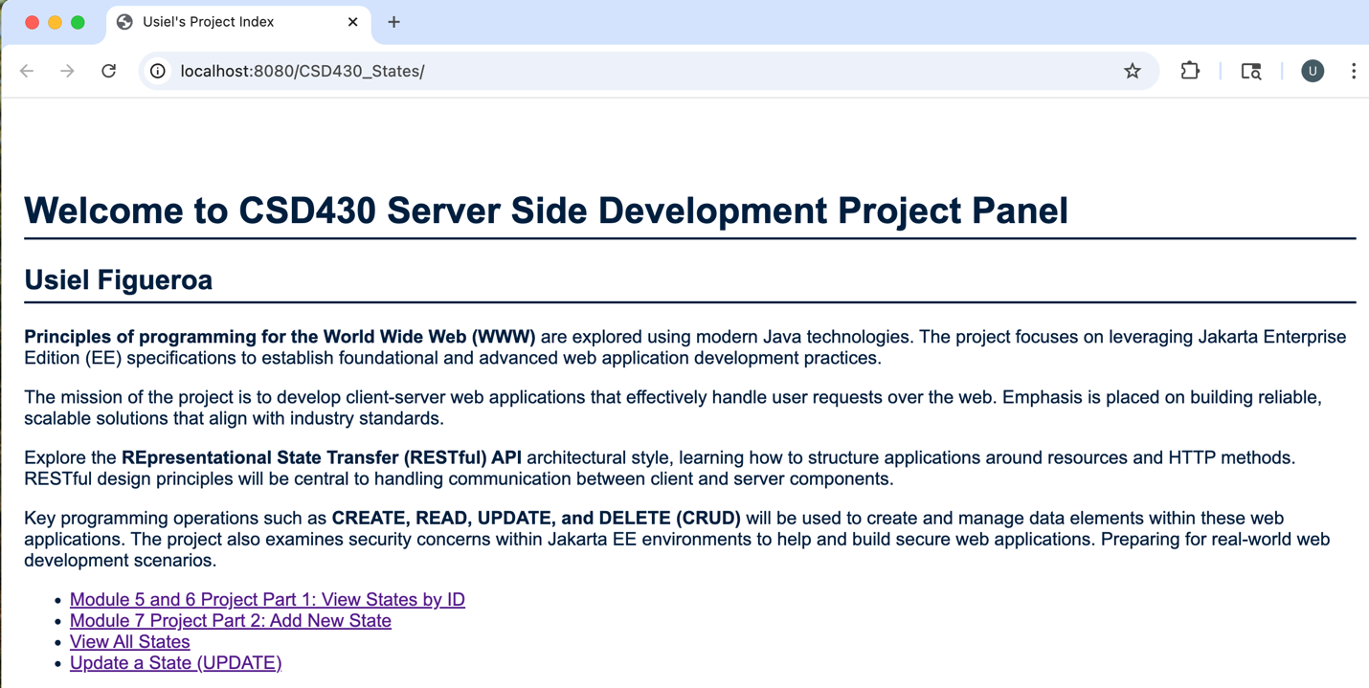

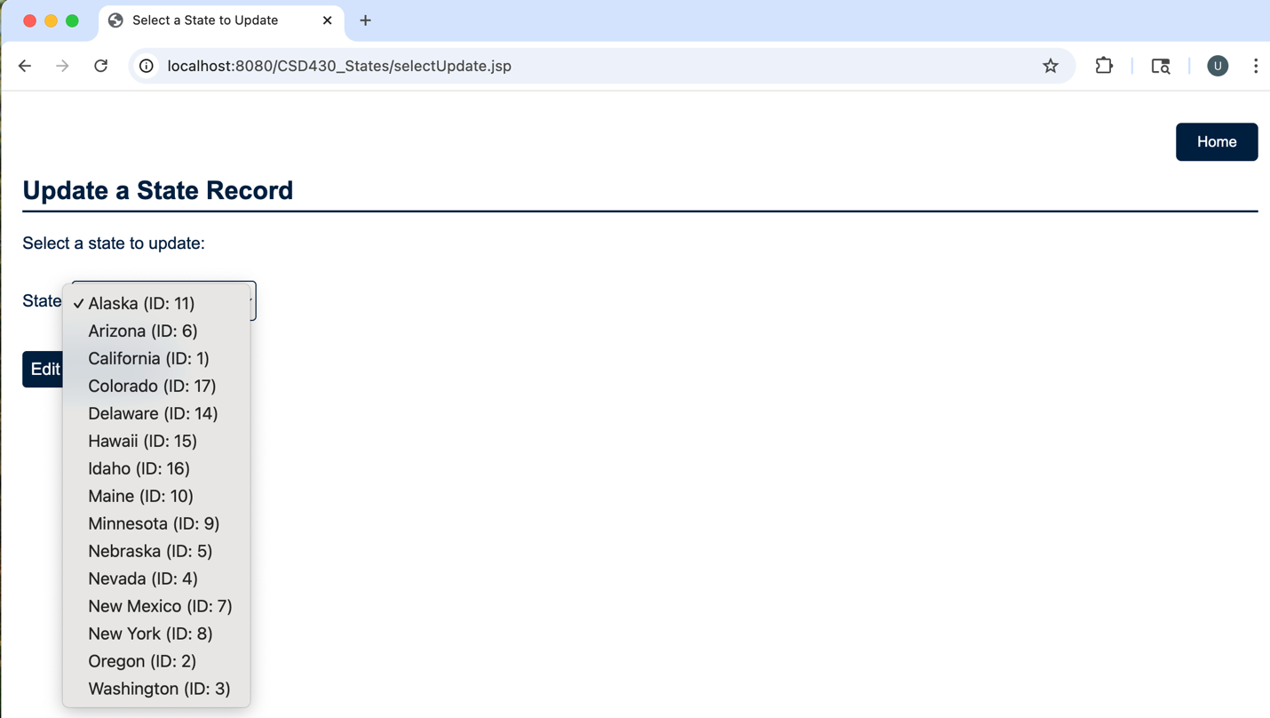

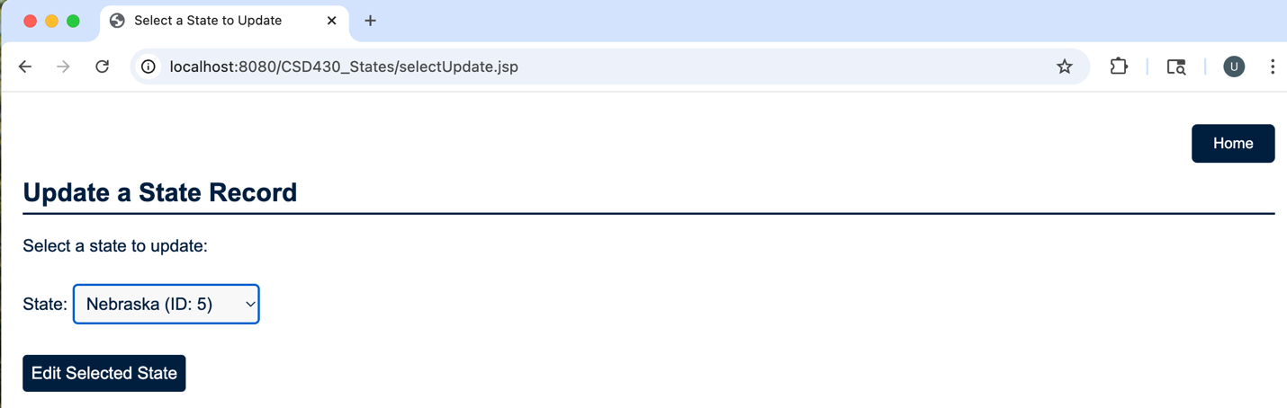

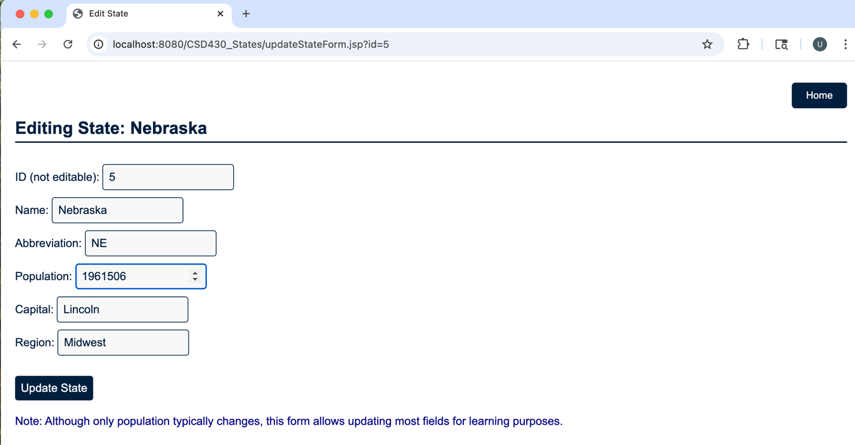

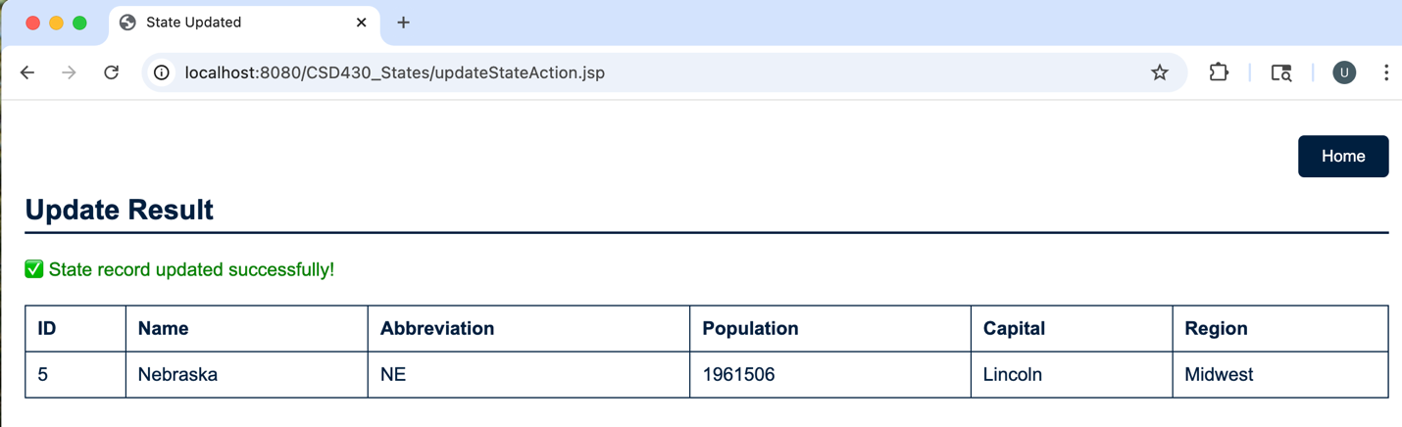

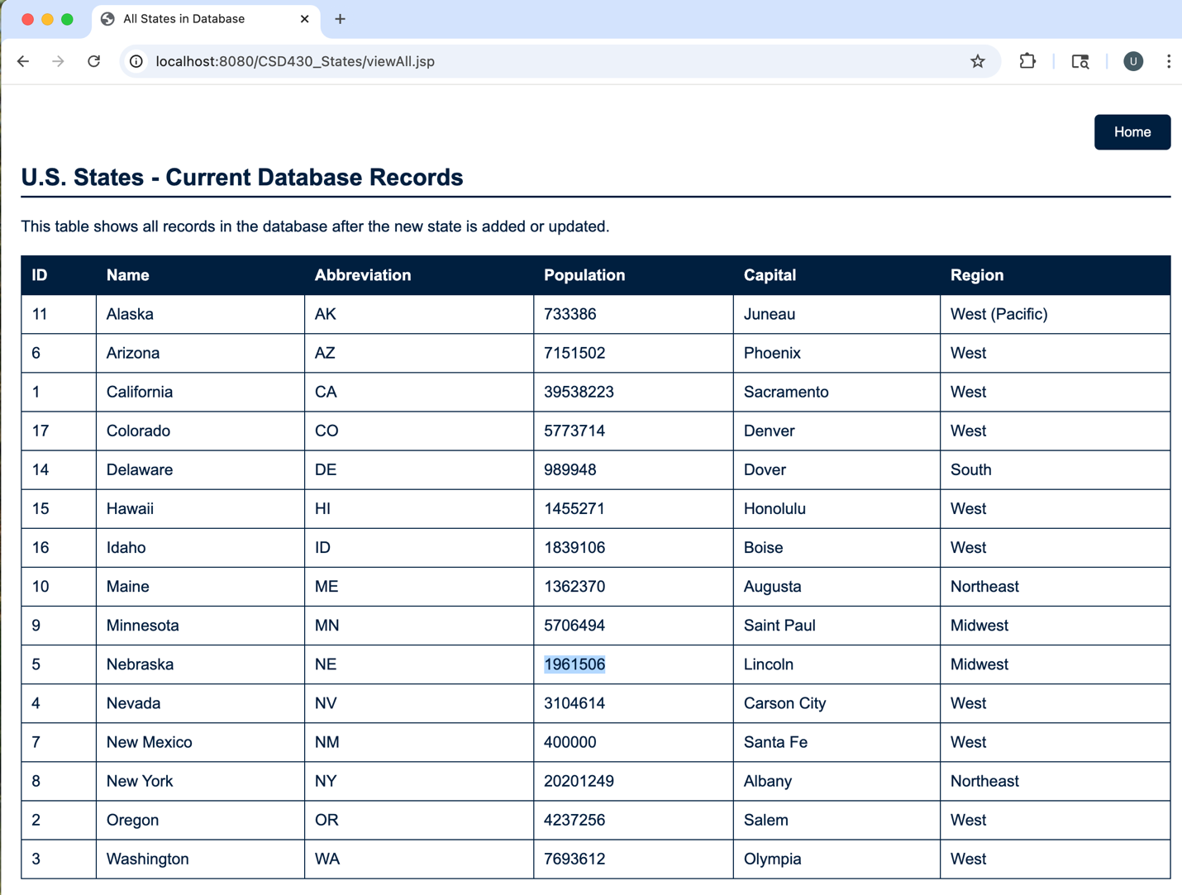

**Files Screenshot**

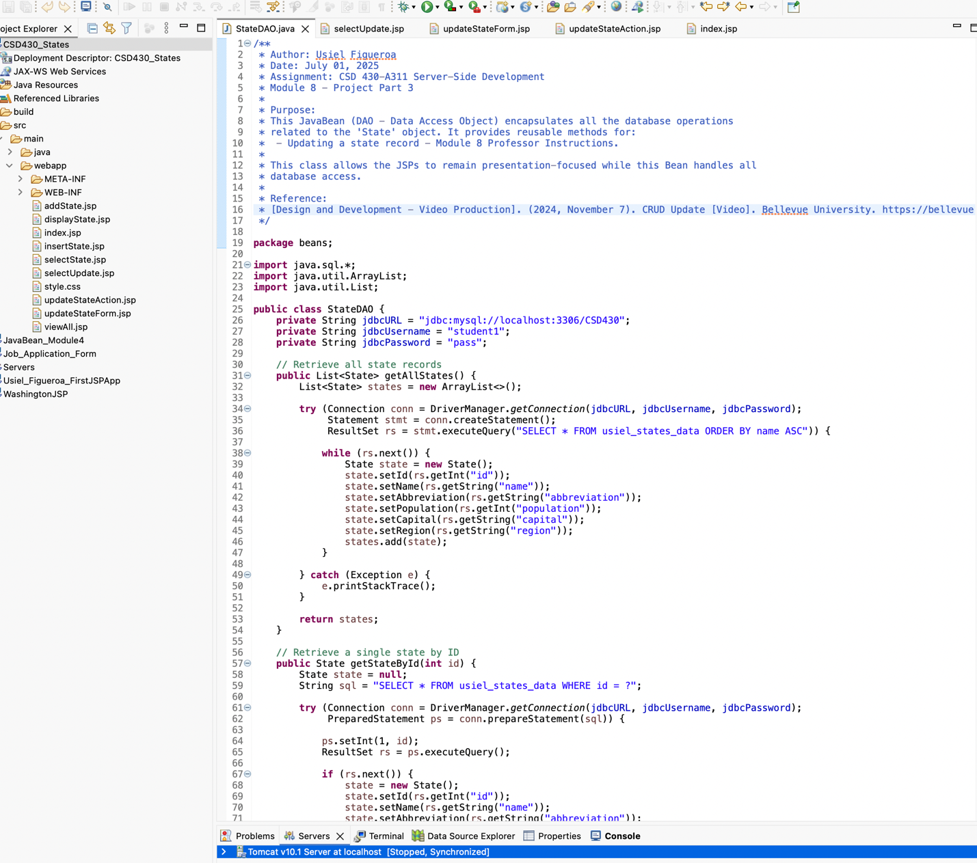

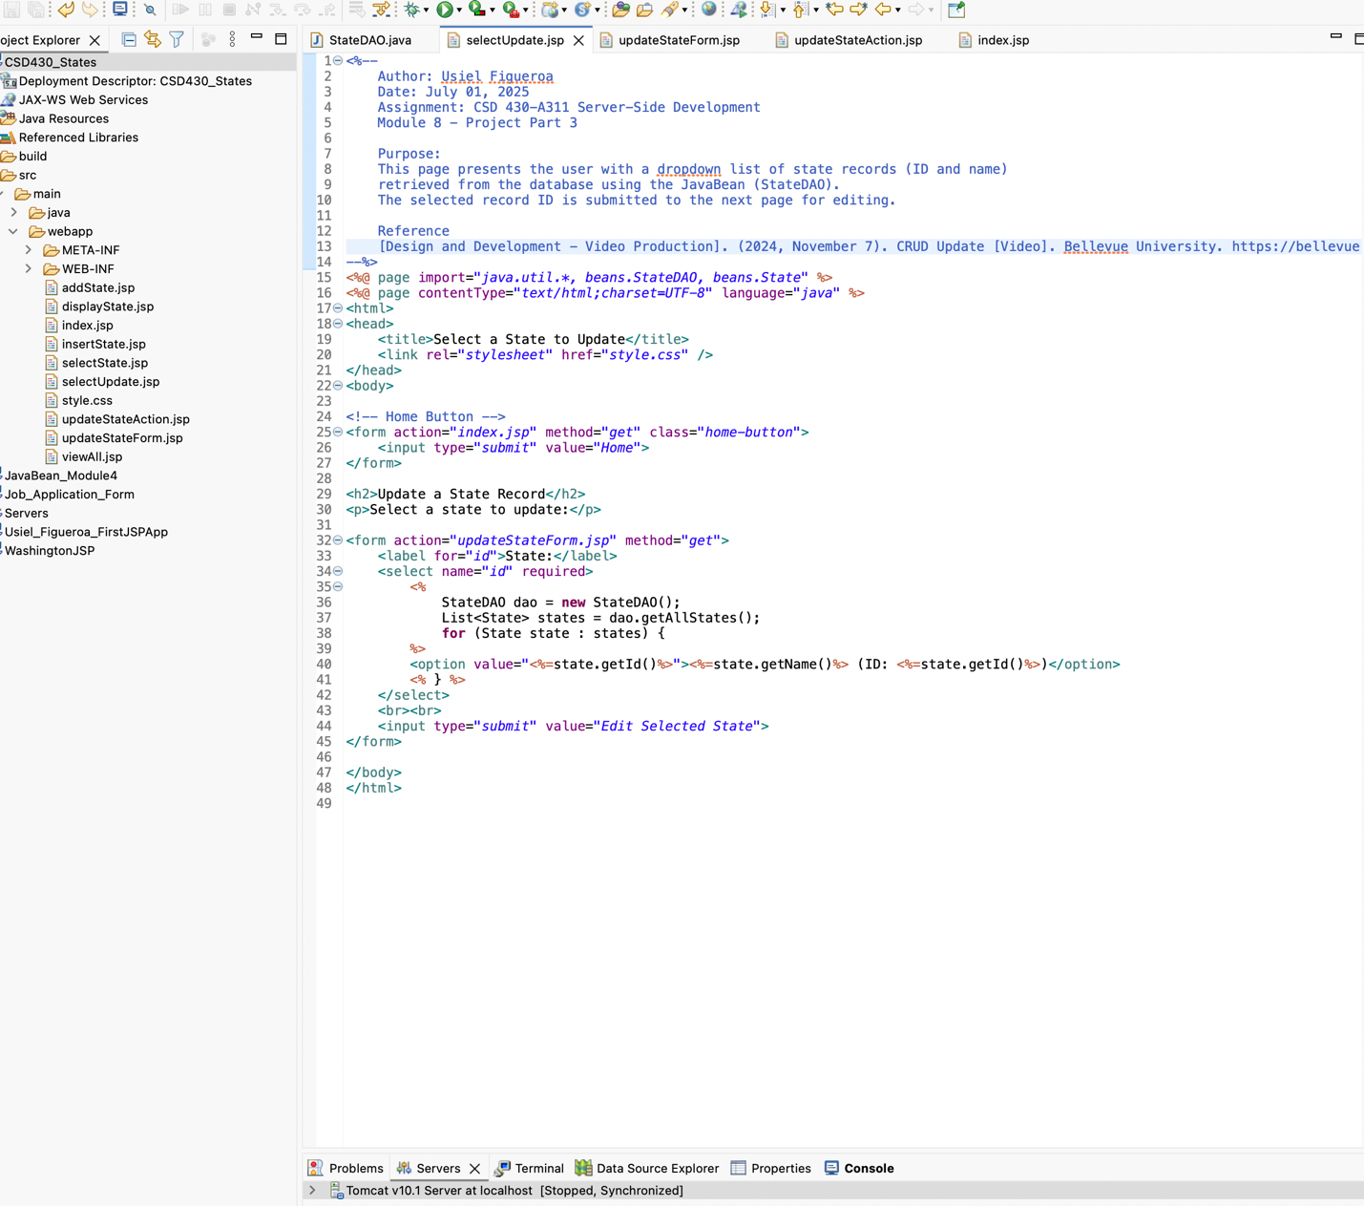

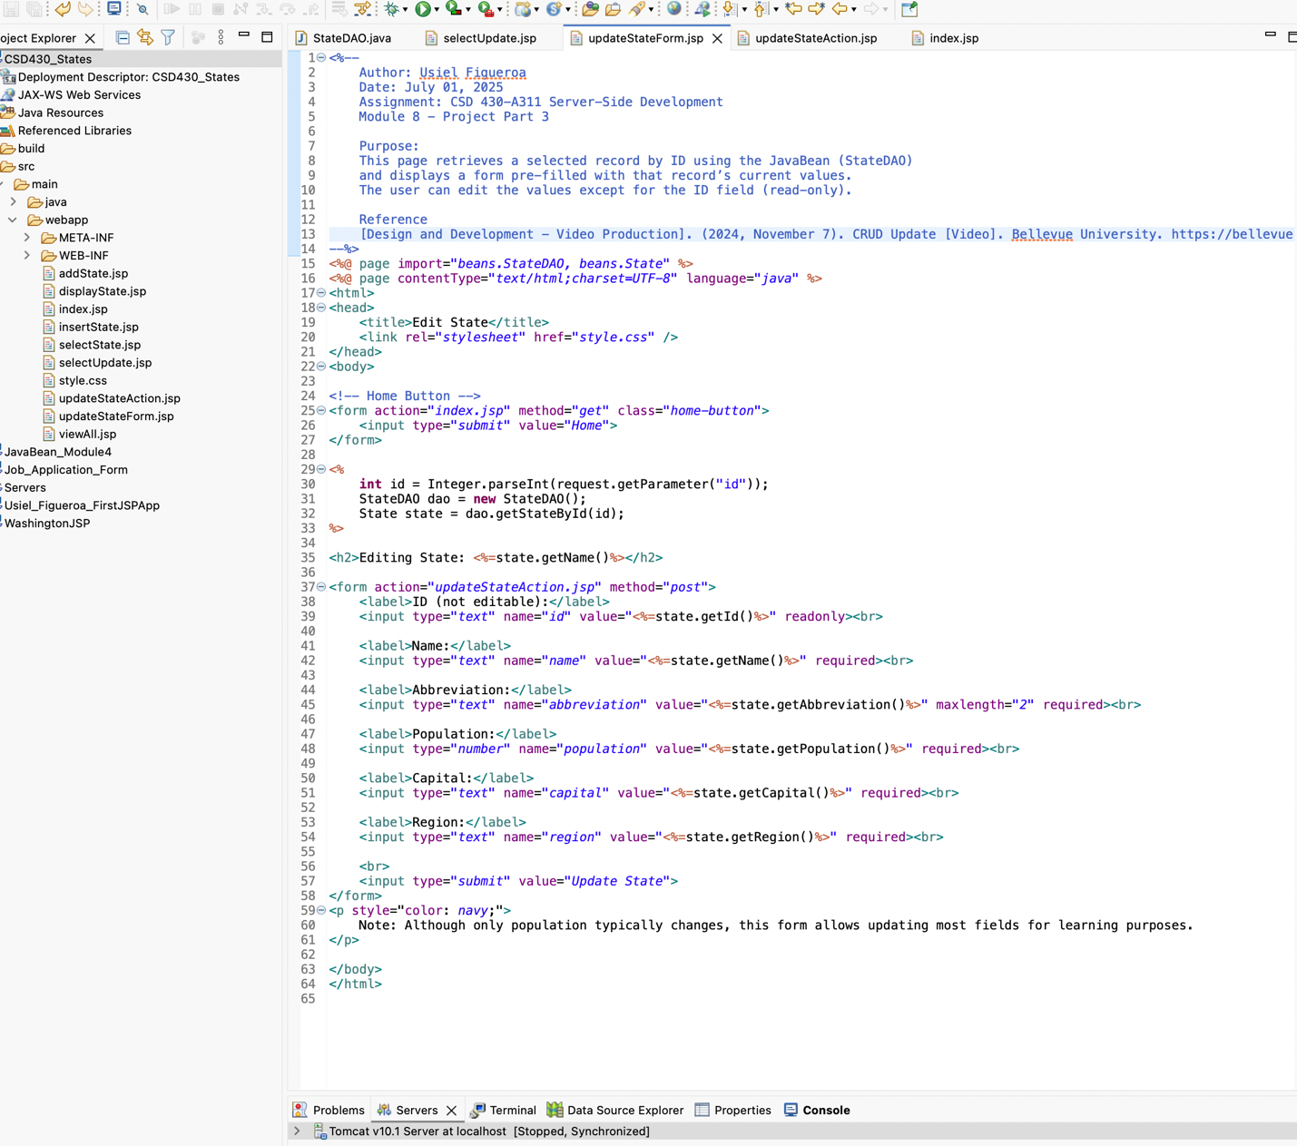

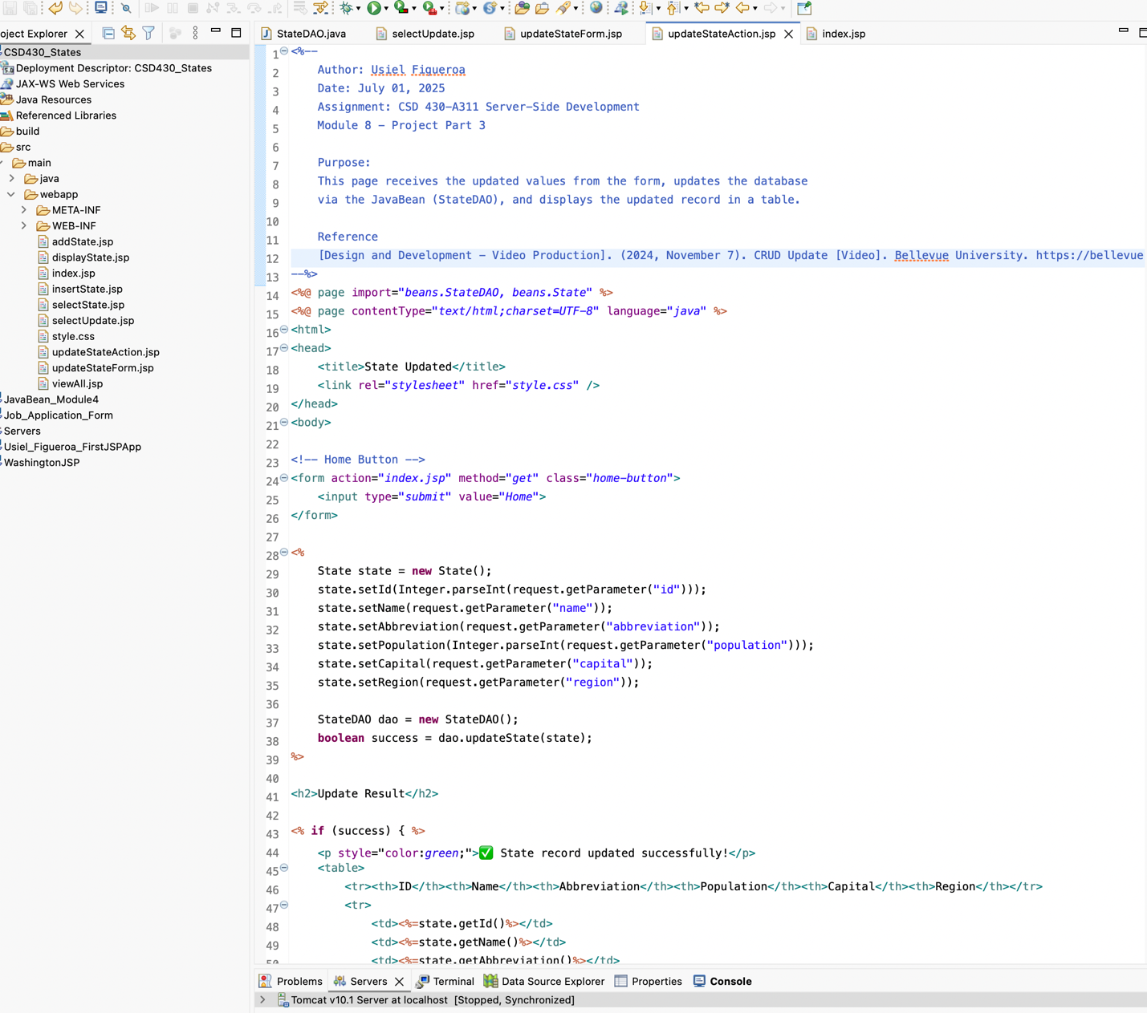

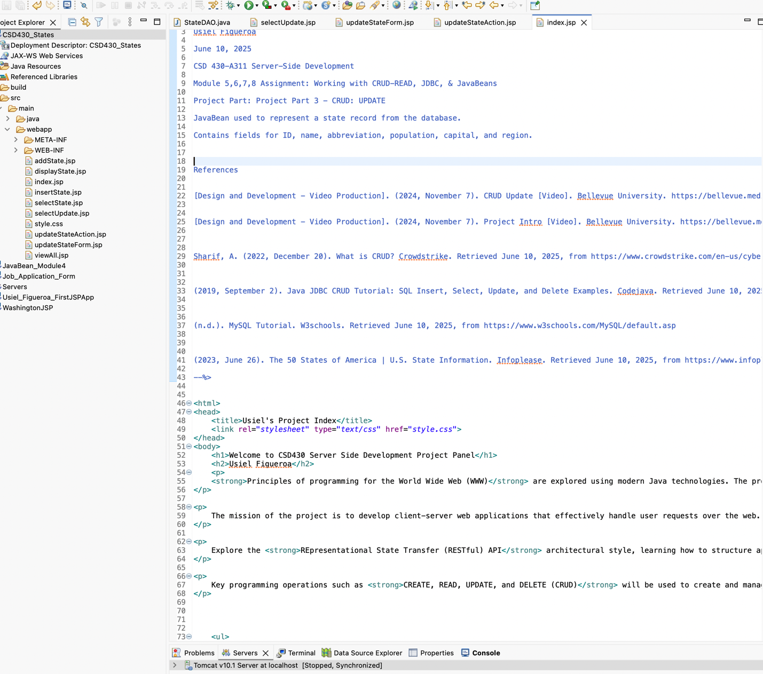

**References**

[Design and Development - Video Production]. (2024, November 7). *CRUD Update* [Video]. Bellevue University. https://bellevue.mediaspace.kaltura.com/media/CRUD+Update/1_nbbhpkdp

[Design and Development - Video Production]. (2024, November 7). Project Intro [Video]. Bellevue University. <https://bellevue.mediaspace.kaltura.com/media/Project+Intro/1_ciyf4naf>

Sharif, A. (2022, December 20). What is CRUD? Crowdstrike. Retrieved June 10, 2025, from <https://www.crowdstrike.com/en-us/cybersecurity-101/observability/crud/>

(2019, September 2). Java JDBC CRUD Tutorial: SQL Insert, Select, Update, and Delete Examples. Codejava. Retrieved June 10, 2025, from <https://www.codejava.net/java-se/jdbc/jdbc-tutorial-sql-insert-select-update-and-delete-examples>

(n.d.). MySQL Tutorial. W3schools. Retrieved June 10, 2025, from <https://www.w3schools.com/MySQL/default.asp>

(2023, June 26). The 50 States of America | U.S. State Information. Infoplease. Retrieved June 10, 2025, from <https://www.infoplease.com/us/states>